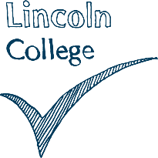

Lincoln College,

Monks Road,

Lincoln,

LN2 5HQ

Dear Student,

Part of the conditional offer to meet entry requirements for Health Level 2 and 3 and Early Year Level 2 and 3 courses is that you provide two positive references. One of these must be an academic reference from your previous school or college provider. This is a mandatory requirement for this course linked to the placement requirements of the qualification.

We are aware that you have not yet provided your two references. You have until

**Friday** **26th September 2025** to submit any outstanding references to the college.

Following your conditional offer for the course, you were sent information about submitting two references to student recruitment. Furthermore, you are required to bring in 3 forms of ID for your DBS check, this will be part of your conditional offer for the course, (information attached) Failure to produce these by **Friday** **26th September 2025** will result in you not meeting the conditions of entry and may therefore mean your place continuing on the course is at risk.

This has also been discussed by staff at late enrolment interviews, during induction week and during CPD sessions. It is essential that you submit these to the college as soon as possible.

I have attached a template which can be given to your chosen referees. Completed references should be emailed to studentrecruitment@lincolncollege.ac.uk or handed in to your course tutor.

Jemma Horsfield

**Curriculum Lead for Care and Early Years**

**HEART, Health and Care**

**Lincoln College Group**  
**Tel:** 01522876000  ext. 6673  
**Email:** jemmahorsfield@lincolncollege.ac.uk